

CSA0501-DATABASE MANAGEMENT SYSTEMS

LAB EXPERIMENTS DATE: 08/07/2026

EXPERIMENT 1 -- DDL Commands (CREATE, ALTER, DROP, TRUNCATE, RENAME)

AIM:
To create and manage the database structure for a Flight Reservation System using Data Definition Language (DDL) commands such as CREATE, ALTER, DROP, TRUNCATE, and RENAME.

PROCEDURE:
- Open MySQL and create the database for the Flight Reservation System.
- Use the CREATE command to create required tables such as Flight, Passenger, and Booking with suitable attributes and data types.
- Use the ALTER command to add, modify, or remove columns from an existing table.
- Use the RENAME command to change the name of an existing table.
- Use the TRUNCATE command to remove all records from a table while keeping its structure.
- Use the DROP command to permanently delete an unwanted table from the database.
- Use DESC table_name; or SHOW TABLES; after the operations to verify the changes.
- Execute each command and observe the output to ensure that all DDL operations are performed successfully.

PROGRAM:

CREATE TABLE

CREATE DATABASE boutique;
USE boutique;
CREATE TABLE products (
product_id INT PRIMARY KEY,
product_name VARCHAR(100) NOT NULL,
category VARCHAR(50) NOT NULL,
size VARCHAR(10),
color VARCHAR(30),
price DECIMAL(10,2) NOT NULL,
stock_quantity INT DEFAULT 0
);
SELECT * FROM products;

OUTPUT:
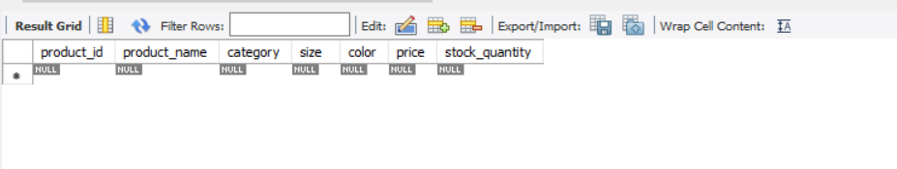

ALTER – ADD COLUMN

USE boutique;
ALTER TABLE products
ADD brand VARCHAR(50);
SELECT * FROM products;

OUTPUT:
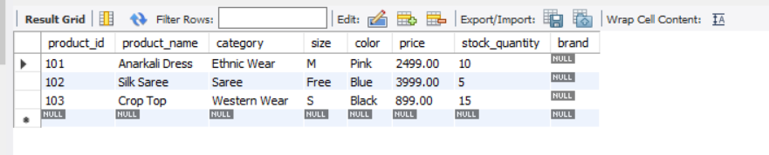

ALTER – MODIFY COLUMN
Change the size of Flight_Name:

USE boutique;
ALTER TABLE products
MODIFY COLUMN price DECIMAL(12,2);
SELECT * FROM products;

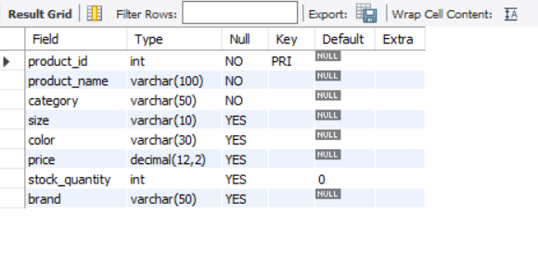

DROP COLUMN

USE boutique;

ALTER TABLE products

DROP COLUMN brand;

SELECT * FROM products;

OUTPUT:

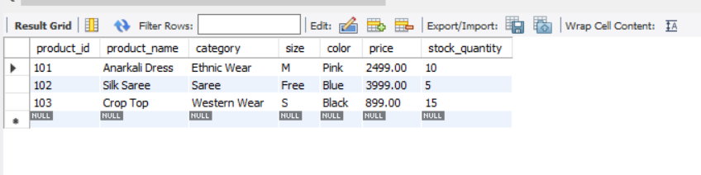

RENAME TABLE
Rename Flight to Flight_Details:

RENAME TABLE Flight TO Flight_Details; SHOW TABLES;

OUTPUT:
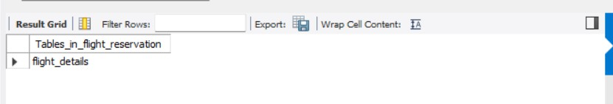

INSERT SAMPLE DATA
INSERT INTO products
VALUES
(101, 'Anarkali Dress', 'Ethnic Wear', 'M', 'Pink', 2499.00, 10),
(102, 'Silk Saree', 'Saree', 'Free', 'Blue', 3999.00, 5),
(103, 'Crop Top', 'Western Wear', 'S', 'Black', 899.00, 15);
SELECT * FROM products;

OUTPUT:



- TRUNCATE TABLE

TRUNCATE TABLE products;

OUTPUT:
